SERVO MG995

This high-speed standard servo can rotate approximately 120 degrees (60 in each direction). And we need only 45degree rotaion for the robotic arm to completely open and close.

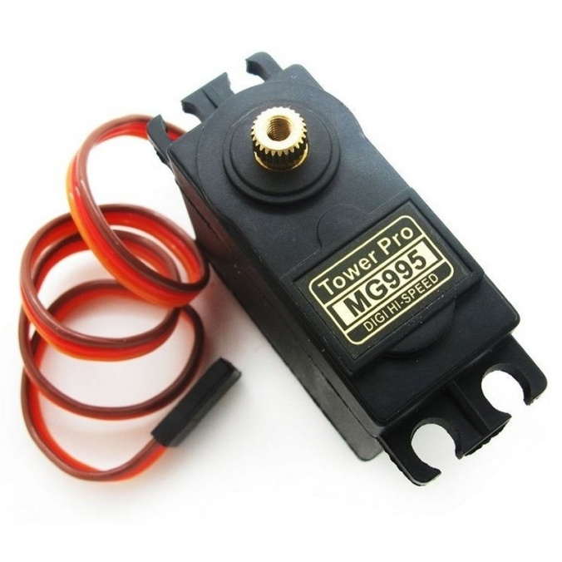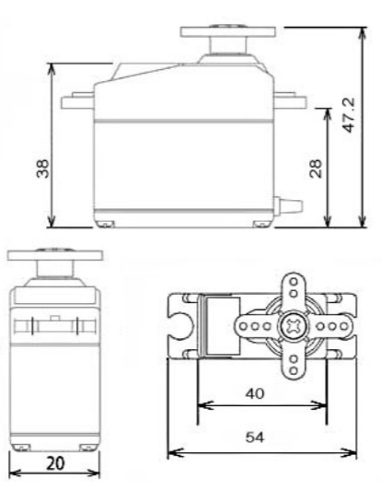

**Specifications**

• Weight: 55 g

• Dimension: 40.7 x 19.7 x 42.9 mm approx.

• Stall torque: 8.5 kgf·cm (4.8 V ), 10 kgf·cm (6 V)

• Operating speed: 0.2 s/60º (4.8 V), 0.16 s/60º (6 V)

• Operating voltage: 4.8 V a 7.2 V

• Dead band width: 5 µs

• Stable and shock proof double ball bearing design

• Temperature range: 0 ºC – 55 ºC

* Weight calculation

Torque given is 8.5 kg-cm for 4.8v supply

Means it can lift upto 8.5 kg with 1 cm of shaft length

Our arm length is 8.5 cm

So

Maximum lifting weight = torque/arm length

=8.5/8.5

=1 kg

* Maximum arm opening is 11.3 cm ,so maximum holding length is 11.3cm .

It is supposed to hold objects of 2cm to 10 cm more precisely.

* Arm opening time

Speed given is 0.2 sec/60deg

Therefore for 45 degree rotation it will take

( 0.2)45/60= 0.15

It means arm will open or close in 150 msec (for full speed).

Comparison table

|  |  |  |
| --- | --- | --- |
|  | **SG90** | **MG995** |
| Input | PWM | PWM |
| voltage | 4.8v-5v | 4.8v-7.2v |
| Rotation angle | 360 degree | **120 degree** |
| Maximum torque | 1 KG | **8.5 KG** |
| Max lifting weight with 8.5cm shaft | 294 Grams | **1000 Grams** |
| Arm opening time | **12.5 msec** | 150 msec |
| Weight | **14.7 g** | 55 g |
| Dimensions | **32 x 12 x 32 mm** | 40.7 x 19.7 x 42.9 mm |

Reference <https://www.towerpro.com.tw/product/mg995/>